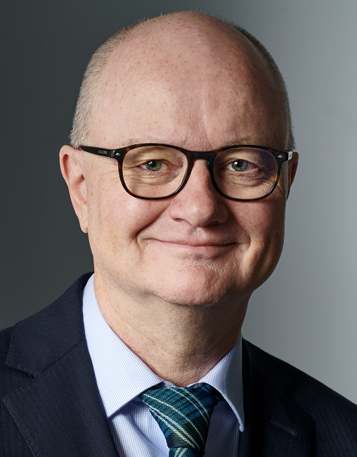

Curriculum Vitae – BERNARD VOLKEN ___________________________________________________________________________ Attorney-at-Law, Partner, Troller Hitz Troller, 3011 Bern – Switzerland, volken@trollerlaw.ch Nationality: Swiss

STUDIES

1986-1991 University of Fribourg (Switzerland), licentiatus iuris (Master of Laws)

1994 Zurich, Attorney-at-Law, admitted to all Courts of Switzerland

LECTURING /TEACHING ACTIVITIES ___________________________________________________________________________

Since 2007 WIPO expert speaker for Design- and Trademark Law

2011-2015 Zurich University of Applied Sciences, trademark and design law, in the field of a MAS Master of Advanced Studies in Intellectual Property Rights

Since 2017 Professional School of Advanced Training St. Gall, Course Visual Design, copyright, trademark and design law Expert speaker Acts regularly as expert speaker at IP congresses worldwide

Since 2023 Fernfachhochschule Switzerland, sports law

PROFESSIONAL ACTIVITIES ___________________________________________________________________________

1991-1993 Clerk to the District Court of Pfäffikon ZH

1994-1997 Legal Assistant to the Legal Section for patents and designs at the Swiss Federal Institute of Intellectual Property (IPI)

1994-1997 Head of a trademark examination section IPI

1997-1999 Head of the opposition proceedings section IPI

2000 – 2020 Partner at a Law firm

Since 2021 partner at the Law firm Troller Hitz Troller

MEMBERSHIP ___________________________________________________________________________

European Trademark Association (ECTA), Chair of the WIPO LINK committee, member of the Design committee

Trademark Owners Association (MARQUES), Member of Chine team Committee

INTA International Trademark Association

INGRES Swiss Association of IP Attorneys

SAV Swiss Bar Association

EXPERT ACTIVITIES ___________________________________________________________________________ Examination expert for Swiss Patent Attorneys

PUBLICATIONS ___________________________________________________________________________

“Ohne Marke kein Spitzensport”, Anwaltsrevue/Revue de l’avocat, Nr. 9/2022, 23. September 2022, S. 366

“Enforcement of Intellectual Property Rights in Switzerland”, in [www.ipenforcement.info](http://www.ipenforcement.info/), 2022

“Requirements for design protection: global commonalities”, in Research Handbook on Design Law 2021.

„Markenrechtsverletzungen; die Abmahnung“, in «Schweizer IP Handbuch», Helbing Lichtenhahn Verlag, 2. Auflage, 2021

Kommentar Patentgesetz (PatG), Kommentierung Art. 46a (Weiterbehandlung) und Art. 47 (Wiedereinsetzung in den früheren Stand), Stämpfli Verlag 2019

„Immaterialgüterrechte - Geistiges Eigentum“, in „Management-Vademecum, viscom-Jubiläumsbuch, 2019, S. 152 ff.

„Der rechtliche Schutz von Verpackungen“, in „alimenta“, Fachzeitschrift für die Lebensmittelwirtschaft, Ausgabe vom 31.05.2017, S. 16 ff.

Basler Kommentar zum Markenschutz- und Wappenschutzgesetz, Kommentierung der Artikel 10-12, 31-34 MSchG, Vorbem. zu Art. 70-72h MSchG, Art. 70-72h MSchG, Helbling Lichtenhahn Verlag, 2017

„Anmelde- und Durchsetzungsstrategien im Designrecht“, Weblaw Juni 2016

«Die Markenrechtsverletzung», in «Schweizer IP Handbuch», Helbing Lichtenhahn Verlag, 2013

Besprechung des Urteils des Oberlandgerichtshofes München vom 14. Mai 2009 «Designschutz Geländewagen», in «Designschutz in Europa», Band 4,  
Carl Heymanns Verlag 2012

«Marke und Tourismus. Widerspruch oder Schlüssel zum Erfolg?», in «Gedanken zum Schutz von geographischen Zeichen», Festschrift für J. David Meisser,  
Stämpfli Verlag 2012

«Der rechtliche Schutz von Domainnamen», in «Marketingerfolg im Internet», Orell Füssli Verlag, 2003

1997 - 2018 contributing editor to the Journal for Intellectual Property Law, Information Law and Competition Law «sic!»

Patentrecht – Wiedereinsetzung in den früheren Stand  
(Art. 47 Pat6); Wegfall des Hindernisses: AJP 9/96, p. 1166 ff.

Numerous articles such as book reviews and summaries of court judgements

RANKING AND AWARDS

___________________________________________________________________________

Rankings

WTR 1000 2022: The immensely qualified all-rounder is outstanding, hands-on and efficient. He understands IP like no one else on the market and is one of the best to find pragmatic solutions in tough cases.

WTR 1000 2021: A versatile operator, Bernard supports clients in many impactful ways. His prosecution abilities and expansive network amaze both clients and peers, while his hand-on and strategic approach to litigation guarantees crisp results.

WTR 1000 2021: Bernard deftly traverses the contentious/non-contentious divide: Amazing at prosecution and an outstanding and hands-on lawyer, he is great at finding solutions and gets the deal done. To top it off, he is well-connected and super-friendly too.

Who's Who Legal 2022, Trademarks: Bernard Volken receives widespread praise as “a well-known lawyer” who is “extremely active”, especially in trademark litigation. Bernard is rated as “most highly regarded".

Who's Who Legal 2021: The excellent Bernard Volken is well known for his great strategic skills and top-notch work on trademark and design filings and IP enforcement proceedings.

Who's Who Legal 2020: Bernard Volken is lauded as a top attorney and very experienced, with a wealth of knowledge in the prosecution and enforcement of trademarks.

WTR 1000 2020: He handles more dossiers than any other practitioner. Fun to work with, he finds solutions quickly and really gets into the nitty gritty of the issues at hand.

Who's Who Legal 2019, Global Guide: Bernard is well respected internationally as an invaluable resource in trademark infringement and protection matters.

Who's Who Legal 2019: Bernard is one of the best lawyers in Switzerland.

Chambers & Partners 2019: Bernard is admired for his skill in IP-related litigation. He offers experience in a range of IP matters, receiving particular praise for his work on trademarks and unfair competition.

WTR 1000 2019: He is a go-to lawyer and outstanding hands-on practitioner. He is highly experienced in both prosecution and enforcement. He considers matters strategically before providing efficient, timely and to-the-point solutions.

Who’s Who Legal 2017, 2018, 2019 and 2020: Ranked as most highly regarded Attorney-at-law in Switzerland in the field of Trademarks.

Who’s Who Legal 2018: Top of the line when it comes to trademarks, impresses with his pragmatic and precise communication, responsive and creative counsel.

WTR 1000 2017: He is a terrific, pragmatic and solutions-oriented all-rounder, although he is perhaps best known for his contentious prowess. He is brilliant on the courtroom floor. He is persuasive and extremely good at client handling – quite extraordinary.

Chambers Europe 2016: He is a solution-oriented and skilful lawyer.

WTR 1000 2015: A terribly bright litigator with incredible experience in prosecution also.

Who’s Who Legal 2014: Bernard is an expert on all aspects of trademark law, approachable, flexible and efficient.

Chambers Europe 2015: He is to the point and an excellent adviser with a very pragmatic and business-oriented approach.

Client Choice International 2014: He has been praised as outstanding in terms of professionalism.

Awards

Trademark Lawyer of the Year, Switzerland, 2023 (The Legal 100)

IP Lawyer of the Year in Switzerland 2023 (Corporate INTL Global Awards Winner)

IP Lawyer of the Year 2022 (corporateamericatoday.com)

IP Law Expert of the Year 2022 in Switzerland ([leaders-in-law.com](http://www.leaders-in-law.com/))

Trademark Lawyer of The Year 2022, Switzerland ([leaders-in-law.com](http://www.leaders-in-law.com/))

Trademark Lawyer of the Year 2022, Switzerland (Global 100)

IP Lawyer of the Year 2022, Switzerland (The Lawyer Network)

IP Lawyer of the year in Switzerland 2022 (globallawexperts.com)

IP Lawyer of the Year in Switzerland 2022 (Corporate INTL Global Awards Winner)

IP Lawyer of the Year 2021 (Global 100)

Trademark Lawyer of the year in Switzerland 2021 (globallawexperts.com)

IP Lawyer of the Year in Switzerland 2021 (Corporate INTL Global Awards Winner)

Who’s Who Legal, Lawyer of the year 2019 für die Schweiz in der Kategorie Markenrecht

Gewinner des «ILO (InternationalLawOffice.com) Client Choice Award 2014» für die Schweiz in der Kategorie Immaterialgüterrecht.

Gewinner des «ILO (InternationalLawOffice.com) Client Choice Award 2011» für die Schweiz in der Kategorie Immaterialgüterrecht.

LANGUAGES ___________________________________________________________________________

Native language: German Fluent in English and French Good knowledge of Italia